**Practical 3**

**Programming Activities and fragments**

Activity Life Cycle, Activity methods, Multiple Activities, Life Cycle of fragments and multiple fragments.

# Activity Life Cycle

## The various methods to be created are onStart(), onRestart(), onStop(), onResume(),onDestroy() and onPause() as shown in the figure.

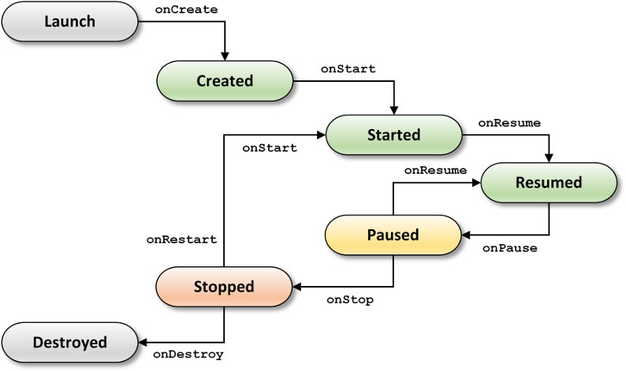

Create a new project and go to, **MainActivity.java**

### **package** MaharashtraCollege.example.profshahidansari;

**import** androidx.appcompat.app.AppCompatActivity;

**import** android.os.Bundle;

**import** android.util.Log;

**public class** MainActivity **extends** AppCompatActivity {

String **tag**= **"Android Lifecycle Demonstration"**; @Override

**protected void** onCreate(Bundle savedInstanceState) { **super**.onCreate(savedInstanceState); setContentView(R.layout.***activity_main***); Log.*d*(**tag**,**"In the onCreate() event"**);

### }

**public void** onStart()

### {

**super**.onStart();

Log.*d*(**tag**,**"In the onStart() event"**);

### }

**public void** onRestart()

{ **super**.onRestart();

Log.*d*(**tag**,**"In the onRestart() event"**);

### }

**public void** onPause()

### {

**super**.onPause();

Log.*d*(**tag**,**"In the onPause() event"**);

### }

**public void** onStop()

### {

**super**.onStop();

Log.*d*(**tag**,**"In the onStop() event"**);

### }

**public void** onDestroy()

### {

**super**.onDestroy();

Log.*d*(**tag**,**"In the onDestroy() event"**);

### }

}

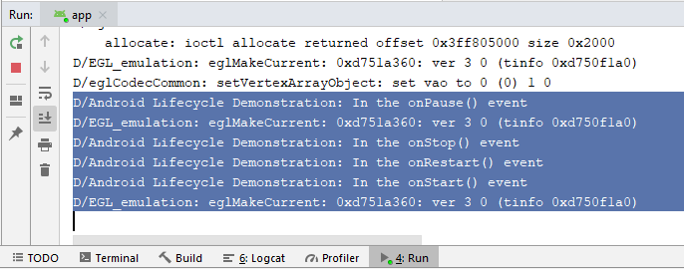

Output

See the Output in Run tab

1. Life Cycle of fragments

Create a new project Add a new Fragment

ProjectName>App>src>main>Java

3. Right click on Java and select **‘Add Fragment’>Add Fragment(Blank)**

Give a name to the fragment and click Finish

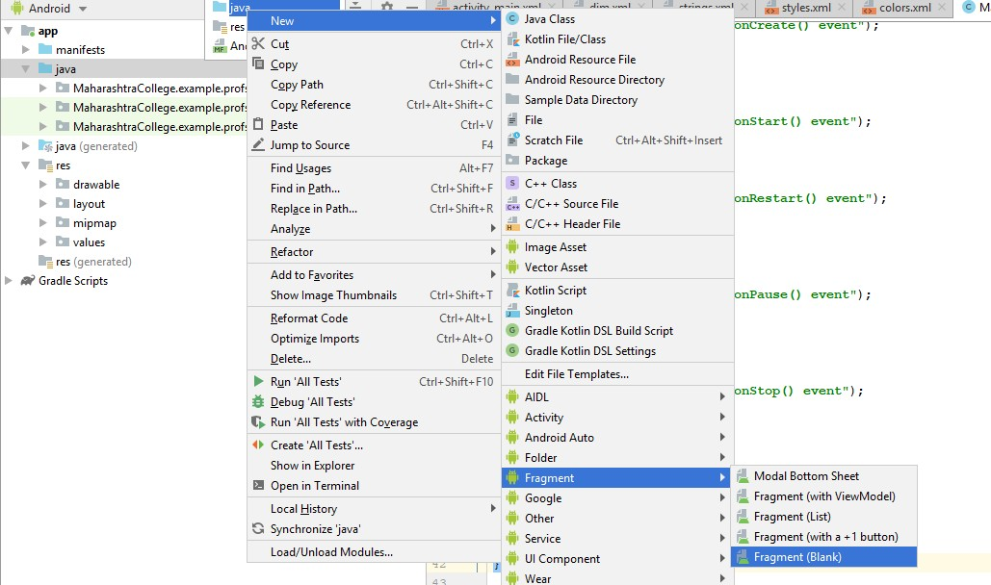

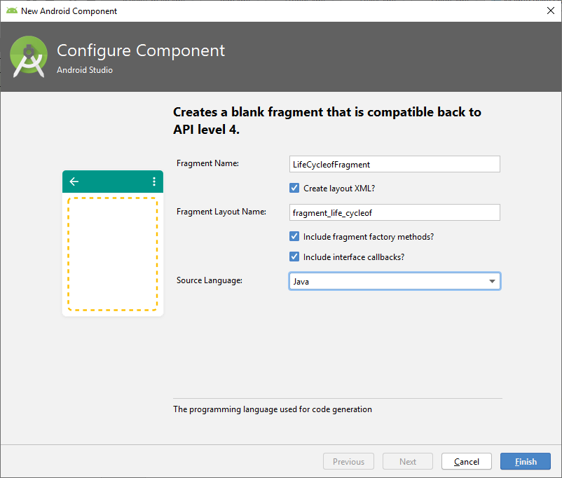

**package** MaharashtraCollege.example.profshahidansari;

**import** android.content.Context;

**import** android.net.Uri;

**import** android.os.Bundle;

**import** androidx.fragment.app.Fragment;

**import** android.view.LayoutInflater;

**import** android.view.View; **import** android.view.ViewGroup; **import** android.util.Log;

**public class** LifeCycleofFragment **extends** Fragment { String **tag** = **"Life Cycle of Fragment"**;

#### // TODO: Rename parameter arguments, choose names that match

*// the fragment initialization parameters, e.g. ARG_ITEM_NUMBER*

**private static final** String ***ARG_PARAM1*** = **"param1"**; **private static final** String ***ARG_PARAM2*** = **"param2"**;

#### // TODO: Rename and change types of parameters

**private** String **mParam1**; **private** String **mParam2**;

**private** OnFragmentInteractionListener **mListener**; **public** LifeCycleofFragment() {

#### // TODO: Rename and change types and number of parameters

**public static** LifeCycleofFragment newInstance(String param1, String param2) {

LifeCycleofFragment fragment = **new** LifeCycleofFragment(); Bundle args = **new** Bundle();

args.putString(***ARG_PARAM1***, param1); args.putString(***ARG_PARAM2***, param2); fragment.setArguments(args); **return** fragment;

}

@Override

**public void** onCreate(Bundle savedInstanceState) {

**super**.onCreate(savedInstanceState); **if** (getArguments() != **null**) {

**mParam1** = getArguments().getString(***ARG_PARAM1***);

**mParam2** = getArguments().getString(***ARG_PARAM2***);

}

}

@Override

**public** View onCreateView(LayoutInflater inflater, ViewGroup container,

Bundle savedInstanceState) {

**false**);

}

*// Inflate the layout for this fragment*

**return** inflater.inflate(R.layout.***fragment_life_cycleof***, container,

#### // TODO: Rename method, update argument and hook method into UI event

**public void** onButtonPressed(Uri uri) {

**if** (**mListener** != **null**) {

**mListener**.onFragmentInteraction(uri);

}

}

@Override

**public void** onAttach(Context context) {

**super**.onAttach(context);

**if** (context **instanceof** OnFragmentInteractionListener) {

**mListener** = (OnFragmentInteractionListener) context;

} **else** {

**throw new** RuntimeException(context.toString()

+ **" must implement OnFragmentInteractionListener"**);

}

}

@Override

**public void** onDetach() { **super**.onDetach(); **mListener** = **null**;

}

**public interface** OnFragmentInteractionListener {

#### // TODO: Update argument type and name

**void** onFragmentInteraction(Uri uri);

}

**public void** onStart()

{

**super**.onStart();

Log.*d*(**tag**,**"In the onStart() event"**);

}

**public void** onRestart()

{

Log.*d*(**tag**,**"In the onRestart() event"**);

}

**public void** onPause()

{

**super**.onPause();

Log.*d*(**tag**,**"In the onPause() event"**);

}

**public void** onStop()

{

**super**.onStop();

Log.*d*(**tag**,**"In the onStop() event"**);

}

**public void** onDestroy()

{

**super**.onDestroy();

Log.*d*(**tag**,**"In the onDestroy() event"**);

}

}

# Output

